Mushroom Classification Problem:

Data Description:

Attribute Information: (classes: edible=e, poisonous=p) cap-shape: bell=biconical=c,convex=x,flat=f, knobbed=k,sunken=s cap-surface: fibrous=f,grooves=g,scaly=y,smooth=s cap-color: brown=n,buff=b,cinnamon=c,gray=g,green=r,pink=p,purple=u,red=e,white=w,yellow=y bruises: bruises=t,no=f odor: almond=a,anise=l,creosote=c,fishy=y,foul=f,musty=m,none=n,pungent=p,spicy=s gill-attachment: attached=a,descending=d,free=f,notched=n gill-spacing: close=c,crowded=w,distant=d gill-size: broad=b,narrow=n gill-color: black=k,brown=n,buff=b,chocolate=h,gray=g, green=r,orange=o,pink=p,purple=u,red=e,white=w,yellow=y stalk-shape: enlarging=e,tapering=t stalk-root: bulbous=b,club=c,cup=u,equal=e,rhizomorphs=z,rooted=r,missing=? stalk-surface-above-ring: fibrous=f,scaly=y,silky=k,smooth=s stalk-surface-below-ring: fibrous=f,scaly=y,silky=k,smooth=s stalk-color-above-ring: brown=n,buff=b,cinnamon=c,gray=g,orange=o,pink=p,red=e,white=w,yellow=y stalk-color-below-ring: brown=n,buff=b,cinnamon=c,gray=g,orange=o,pink=p,red=e,white=w,yellow=y veil-type: partial=p,universal=u veil-color: brown=n,orange=o,white=w,yellow=y ring-number: none=n,one=o,two=t ring-type: cobwebby=c,evanescent=e,flaring=f,large=l,none=n,pendant=p,sheathing=s,zone=z spore-print-color: black=k,brown=n,buff=b,chocolate=h,green=r,orange=o,purple=u,white=w,yellow=y population: abundant=a,clustered=c,numerous=n,scattered=s,several=v,solitary=y habitat: grasses=g,leaves=l,meadows=m,paths=p,urban=u,waste=w,woods=d

Domain Knowledge:

Feature Glossary:

* Cap (Pileus): the expanded, upper part of the mushroom; whose surface is the pileus
* Cup (Volva): a cup-shaped structure at the base of the mushroom. The basal cup is the remnant of the button (the rounded, undeveloped mushroom before the fruiting body appears). Not all mushrooms have a cup.
* Gills (Lamellae): a series of radially arranged (from the center) flat surfaces located on the underside of the cap. Spores are made in the gills.
* Mycelial threads: root-like filaments that anchor the mushroom in the soli.
* Ring (Annulus): a skirt-like ring of tissue circling the stem of mature mushrooms. The ring is the remnant of the veil (the veil is the tissue that connects the stem and the cap before the gills are exposed and the fruiting body develops). Not all mushrooms have a ring.
* Scale: rough patches of tissue on the surface of the cap (scales are remnants of the veil).
* Stalk (or Stem, or Stapes): the main support of the mushroom; it is topped by the cap. Not all mushrooms have a stalk (stem)

Another feature to consider when identifying mushrooms is whether they bruise or bleed a specific color. Certain mushrooms will change colors when damaged or injured. Cutting into a mushroom and observing any color changes can be very important when trying to determine what it is

A universal veil is a temporary membranous tissue that fully envelops immature fruiting bodies of certain gilled mushrooms. The developing Caesar’s mushroom (Amanita caesarea), for example, which may resemble a small white sphere at this point, is protected by this structure. The veil will eventually rupture and disintegrate by the force of the expanding and maturing mushroom, but will usually leave evidence of its former shape with remnants. These remnants include the volva, or cup-like structure at the base of the stipe, and patches or “warts” on top of the cap.

A partial veil (also called an inner veil, to differentiate it from the “outer” veil, or velum) is a temporary structure of tissue found on the fruiting bodies of some basidiomycete fungi, typically agarics. Its role is to isolate and protect the developing spore-producing surface, represented by gills or tubes, found on the lower surface of the cap. A partial veil, in contrast to a universal veil, extends from the stem surface to the cap edge. The partial veil later disintegrates, once the fruiting body has matured and the spores are ready for dispersal. It might then give rise to a stem ring, or fragments attached to the stem or cap edge. In some mushrooms, both a partial veil and a universal veil may be present.

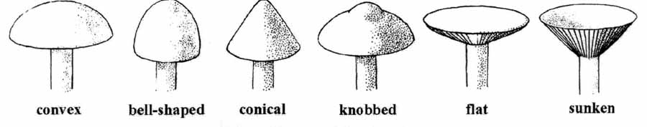

Figure: mushroom cap shape

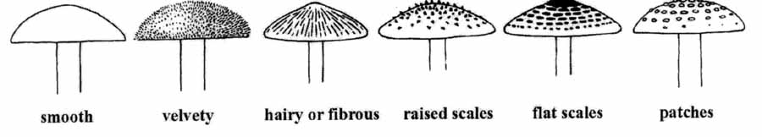

Figure: Mushroom cap surface

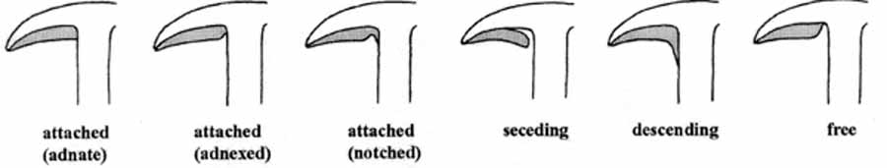

Figure: Mushroom gill attachment

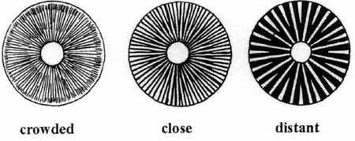

Figure: Mushroom gill spacing

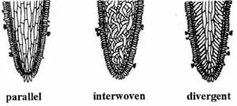

Figure: Mushroom Gill tissue arrangement

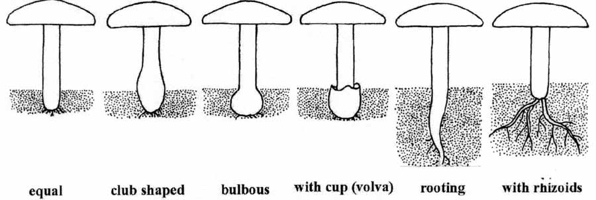

Figure: Mushroom Stalk

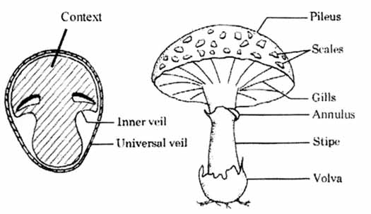

Figure: Mushroom Glossary